Edge2d version 0.1.0
Copyright © 2007-2008, Kevin Lynx. All rights reserved.

Edge Plug-ins
The essence of plug-ins in Edge is some classes which implement some abstract class declared in Edge base. When you implement the graphics module using Direct3D8, that will be called D3D8Graphics plug-in. whatever it’s simple.
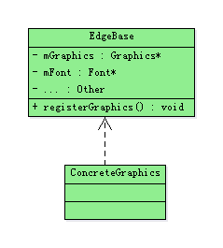
Like the pictures showed above, Edge maintains many pointers of any kinds of module. And then plug-ins implement the concrete module, then register itself into Edge.
The plug-ins which can be customized in Edge includes: Graphics module, Input module, Sound module, Image decoder module, Font module, Operation System dependent module and Archive reader module.
The Graphics module manage the rendering in game, input module manages input, sound module manages sound playing, image decoder manages reading data from any kinds of image files, font module will render texts on screen, OS dependent module mainly to create render window and any kinds of Archive can read data from any kinds of compressed data file.

